title: billing details
version: 1.0
date: 18.01.2018

Project Heading
Functional Specification ID: ASSIGNMENT-1
Associated Spec(s): N/A

Conversion Revision | Revision Date | Revision Description | Author
1.0 | 17.01.2018 | Initial Version | GROUP-1

Program Name: | ZG1_ASSIGN1
Tansaction Code: | ZTC_PLP_G1
Developer: | GROUP-1
Business Owner: | - Vandana Koleshwar
Technical Owner: | GROUP-1
Requirement #:
Comments:

Executed By | Date / Time | Pass / Fail

Test objective: TO VERIFY THE FUNCTIONALITY OF THE APPLICATION |  |  |  |  | Program/FM/T-Code: ZTC_PLP_G1
Test Case Seq. No. | Test Description | Step Seq. No. | Step Description | Test Data |  | Expected Results | Actual results | Executed By / Date | Pass /  Fail
- 1 | For Default Values | 1 | For Default Values | VBELN = 4000000001 to 4000000010.  PBELN = 0000000001 to  0000000002. |  | 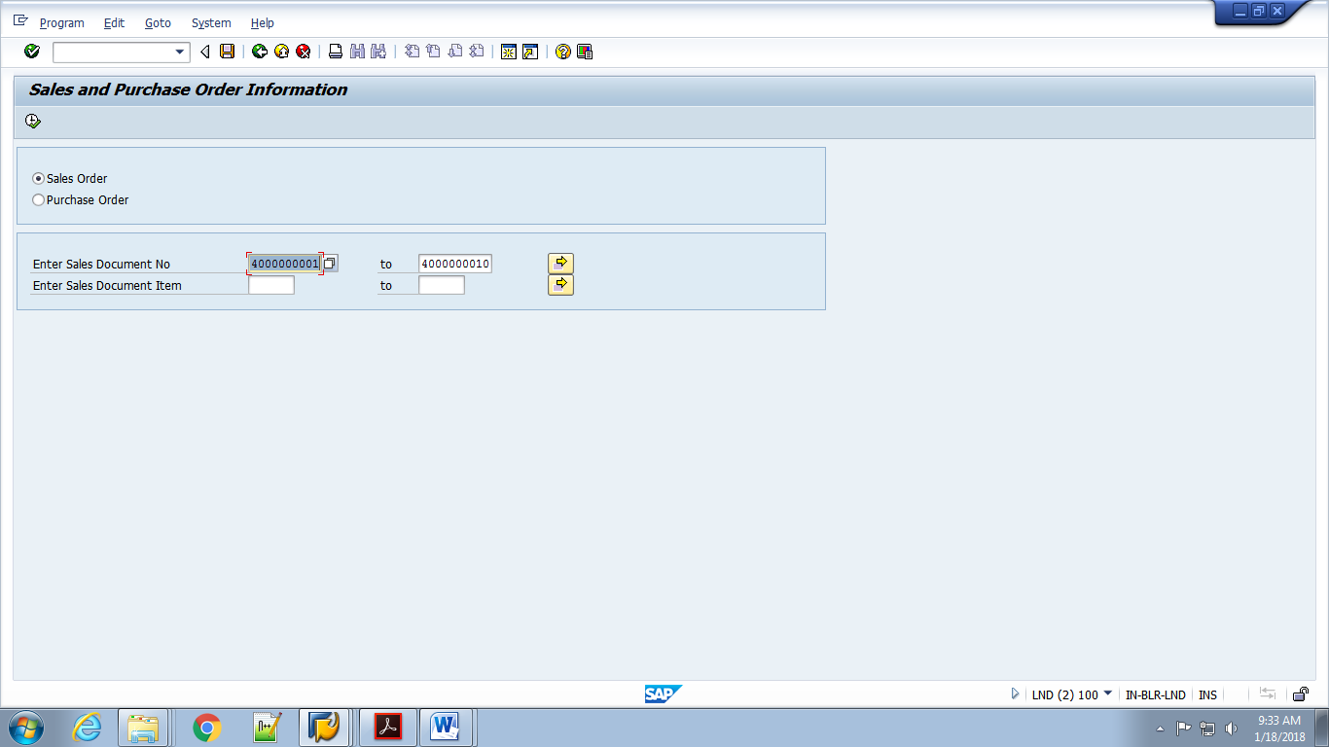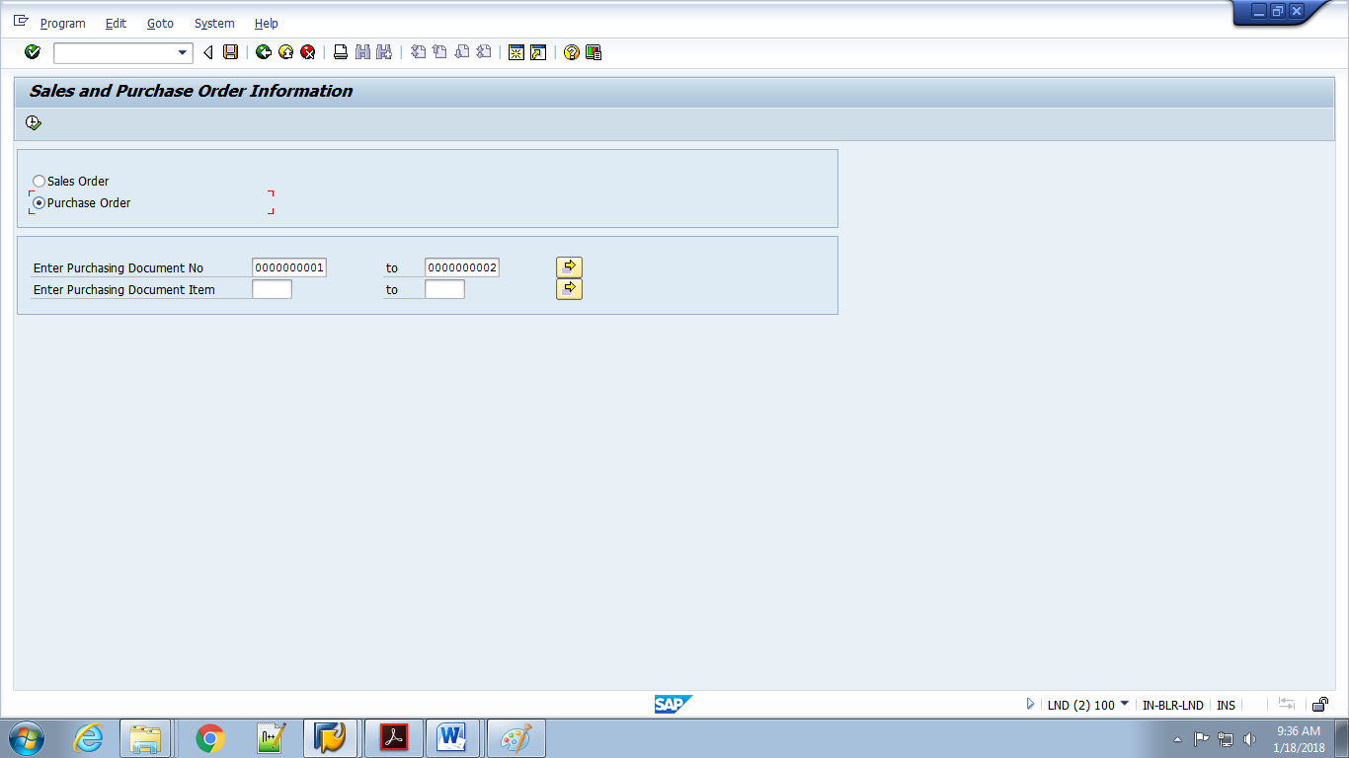 |  |  | - PASS
- 2 | For Valid Input | 1 | For Valid Input | VBELN = 4000000001 to 4000000010  POSNR = 000000 to 000010  PBELN = 0000000001 to  0000000002  EBELP = 00001 to  00010 to 00100. |  | 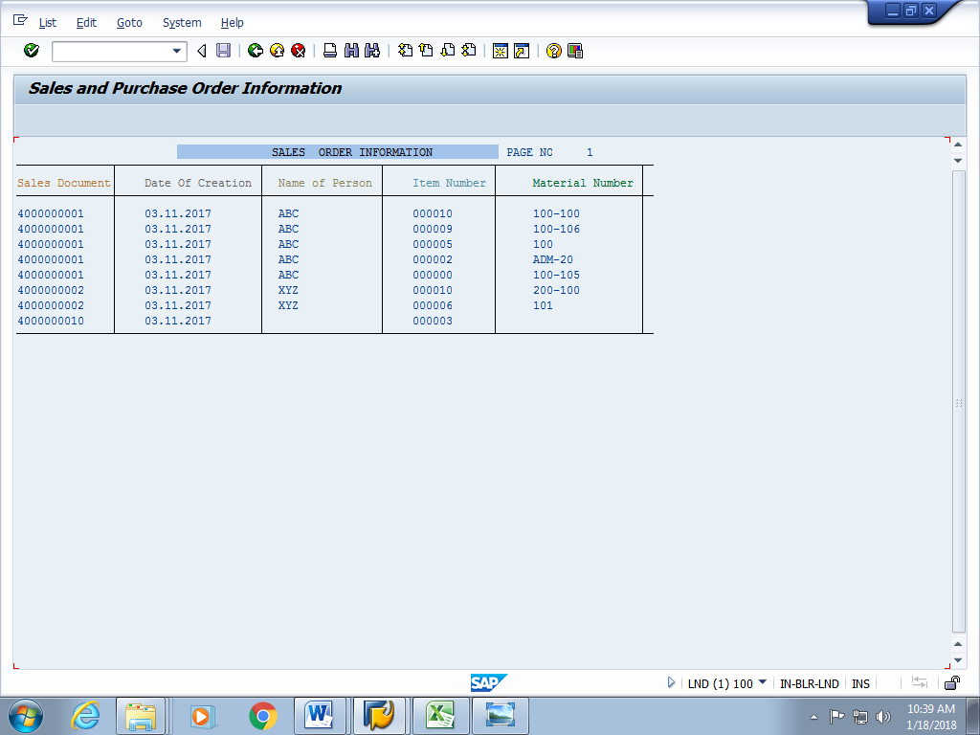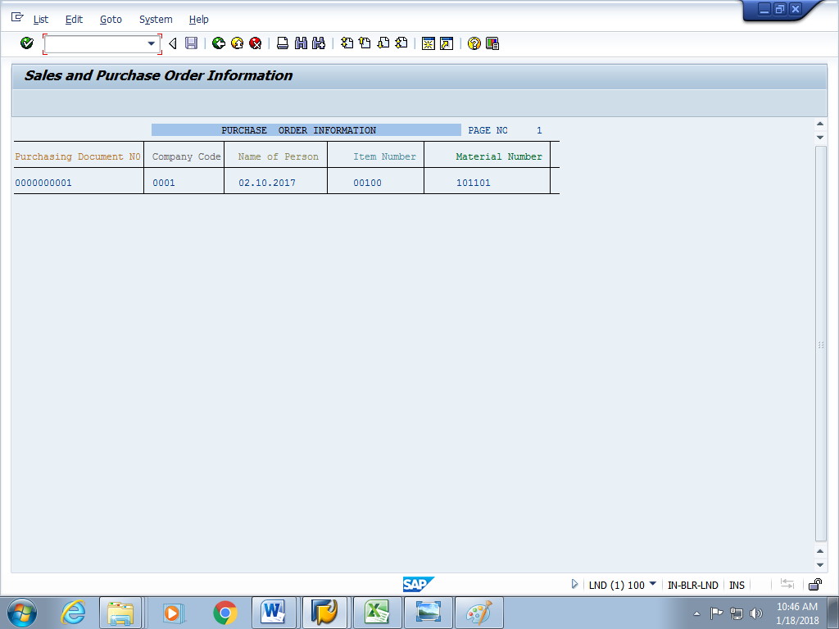 |  |  | - PASS
3 | For Invalid Input | 1 | For Invalid Input | VBELN = 0000000123 to 0000000124  POSNR = 000001 to 000002.  PBELN = 0000000111 to  0000000112  EBELP = 00001 to  00001 to 00002. |  | 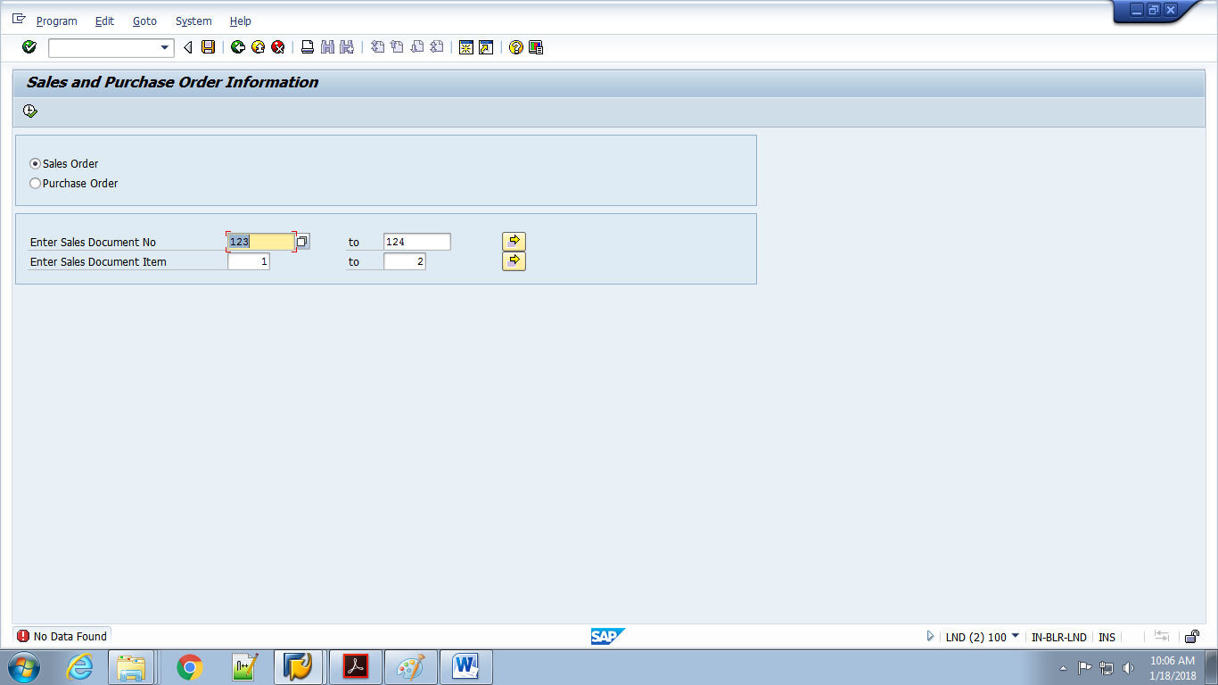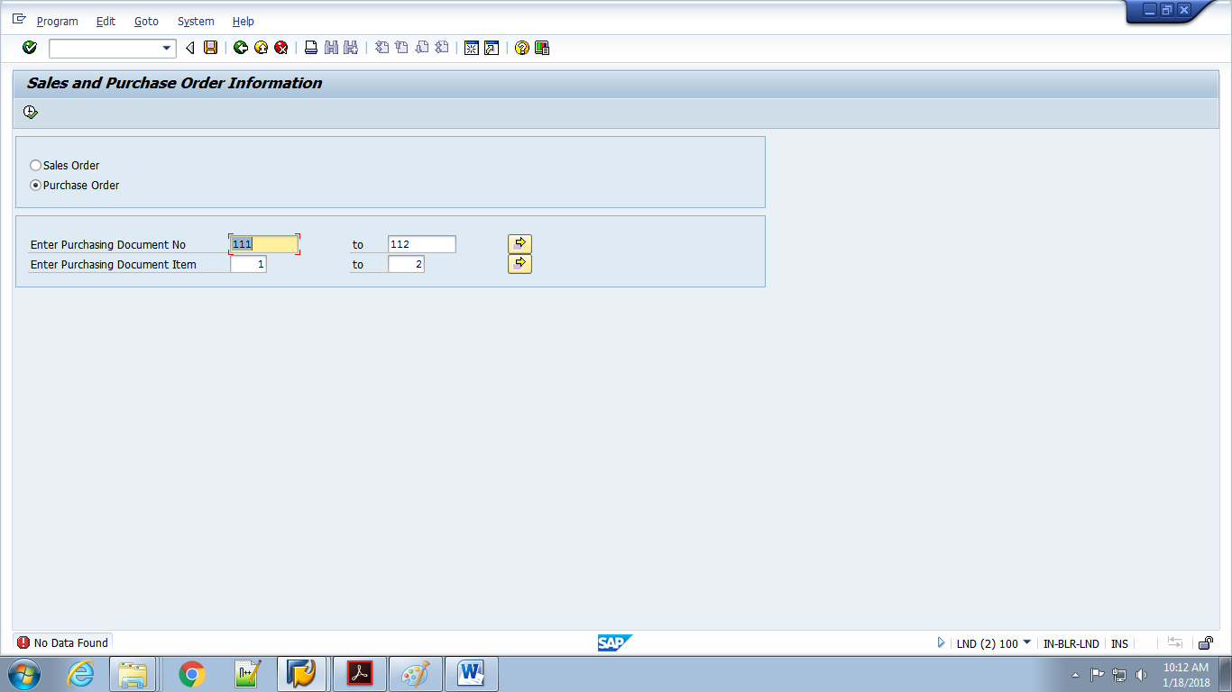 |  |  | - PASS

Note: Use below sections to paste screen capture of actual results, if required, and mention the attachment number in above table.

Test Execution Screen Captures (Repeat below sections as per need):

Attachment No. | Condition Sequence No. | Step Sequence No. | Comment
1 |  |  | SALES ODER SCREENS

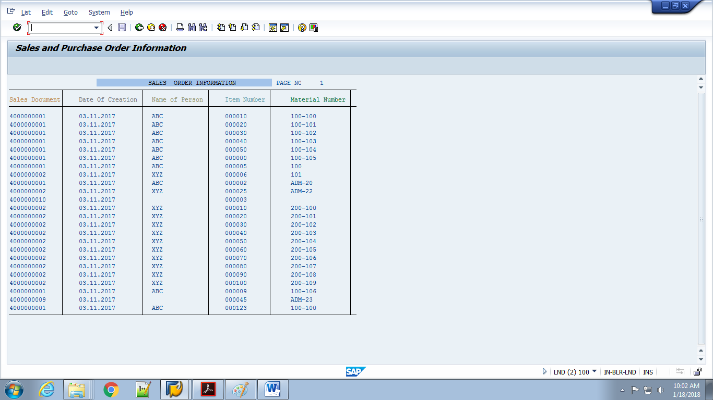

Attachment No. | Condition Sequence No. | Step Sequence No. | Comment
2 |  |  | PURCHASE ORDER SCREENS

